ATD Charlotte Lunch & Learn – Wednesday, February 24, 2021
Selecting goals and setting a path:
Using the ATD Talent Development Capability Model and SDPDC© as a Guide
Kelly D. Smith, Ed.D.

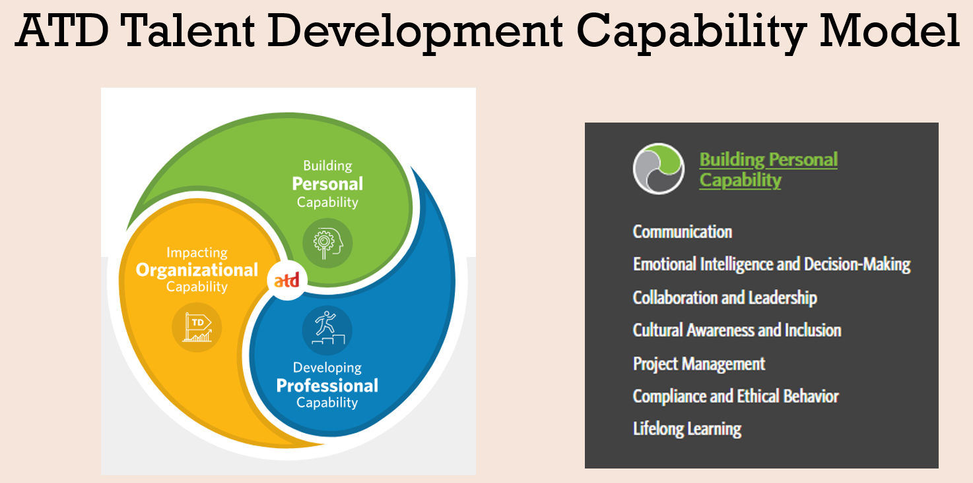
https://tdcapability.org/#/
Model Resources
Definitions of Domains / Capabilities
https://d22bbllmj4tvv8.cloudfront.net/18/5b/1142b292431fb5393f2193211e1b/talent-development-capability-model-definitions.pdf
Understanding Talent Development (job aid)
https://d22bbllmj4tvv8.cloudfront.net/1a/20/393bac544f7b9689fb16ba0f562e/understanding-talent-development-job-aid.pdf
Developing Myself (job aid)
https://d22bbllmj4tvv8.cloudfront.net/65/44/47ccef1d4dc4917ebe4ee946bd25/developing-myself-job-aid.pdf
Self-Assessment Tracking (job aid)
https://d22bbllmj4tvv8.cloudfront.net/29/4b/f734b8b84366a712ca979613a6c5/self-assessment-tracking-job-aid.pdf

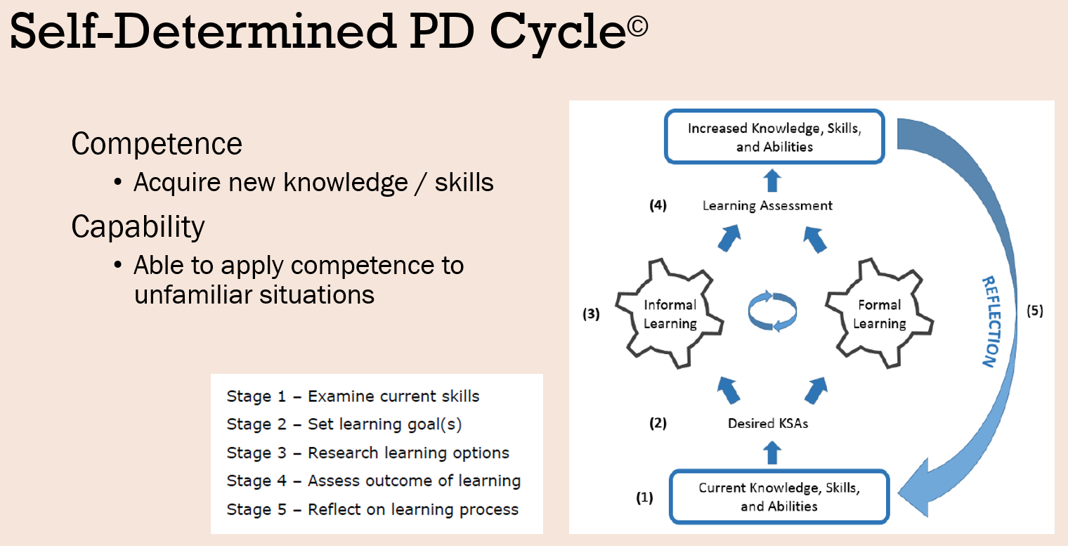

New to SAS®? Helpful hints for developing your own professional development plan. Smith, K. D. (2019, April). SAS Global Forum 2019.
https://www.sas.com/content/dam/SAS/support/en/sas-global-forum-proceedings/2019/3896-2019.pdf
Handout available by email.

Other Resources
https://ocw.mit.edu/
https://www.ted.com/talks
https://www.edx.org/
https://www.coursera.org/
https://www.udemy.com/
https://www.linkedin.com/learning/

Success Tips
- Schedule time for learning
- Find accountability partner(s)
- Look past current role responsibilities
- Explore, read, and take notes
- Create personal resource library
- Competency & Capability

